## Annotated Timeline of Key Shifts in Language and Documentation

This timeline visually reinforces the sequence and shift in language, highlighting how the terminology changed only after several years and under specific circumstances:

1. **2004-2009: Family Support and Gift Characterization**
   1. **November 5, 2004**: Initial transfer of HK$600,000 described as “support” or “mortgage payment.”
   2. **February 2, 2005 - January 11, 2007**: Additional transfers totaling around HK$1.48 million. All transactions use informal support language and show no indication of loan terms.
   3. **January 14, 2007 Email**: Christine’s father explicitly states, “There is no debt,” and addresses both “Robert and you” as “the only owners” of the house. This email shows that these funds were intended as gifts without repayment obligations.
2. **2010: Reclassification as “Interest-Free Loan”**
   1. **January 22, 2010 Email**: This marks the first documented appearance of “interest-free loan” terminology. The email from Christine’s father includes retrospective “Pro Memos” and balance sheets that refer to prior gifts as “interest-free loans” for the first time.
   2. **Balance Sheets and Pro Memos (2011-2012)**: These summaries introduce terms like “inheritance deductions” and attempt to formalize the reclassification. However, they lack the formal features of a genuine loan and are clearly created after the fact to change the original understanding of these funds.
3. **Pre-2010 Consistency vs. Post-2010 Reclassification**
   1. **Pre-2010 Language**: The documentation from 2004 to 2009 consistently uses terms like “support” and “mortgage payment” without any mention of loans.
   2. **Post-2010 Language**: In contrast, the 2010 documentation shift introduces more formal, accounting-oriented terms—“interest-free loan” and “inheritance deduction”—indicating an apparent narrative change rather than a continuation of the original family intent.

This structured comparison and annotated timeline comprehensively respond to Christine’s argument. **The absence of loan standards, combined with the shift in language only in 2010, strongly supports Robert’s position that these funds were originally family gifts.** The checklist and timeline reinforce that these were intended as informal support, without repayment obligations, and that the reclassification does not align with the original intent. Please see the additional visual representation on the following page.

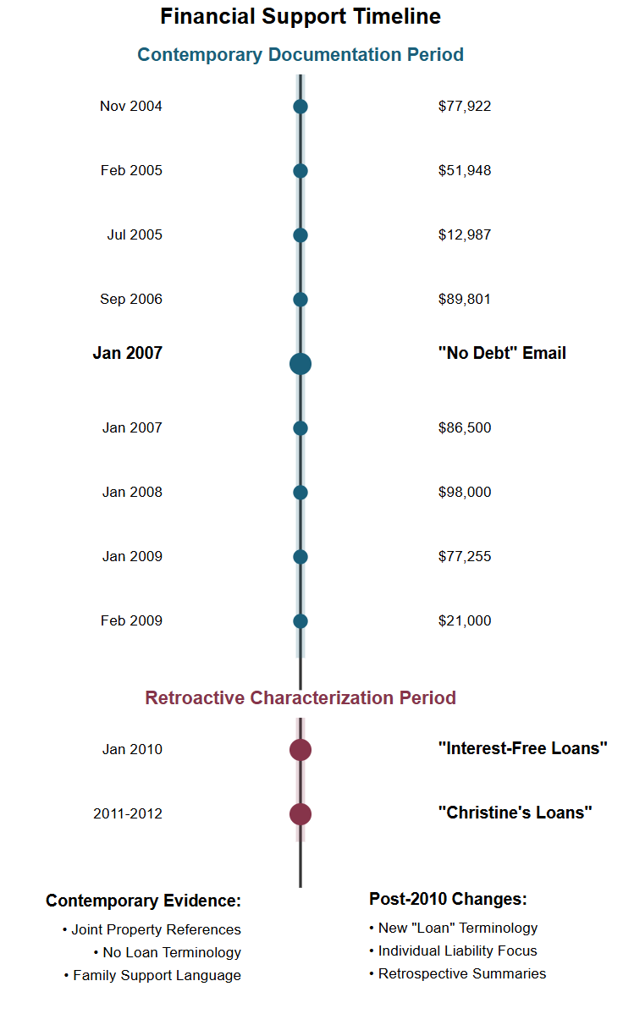

## Introduction and Summary of Findings

The records from 2004 to 2009 make it clear that Christine’s family provided financial support intended for the joint benefit of her and Robert. Notably, every document from this period points to **these funds as gifts directed toward helping them with their shared mortgage on their marital property**. We see consistent phrasing like “support” and “mortgage payment,” indicating informal family assistance. There’s no mention of repayment, loans, or liability attached solely to Christine.

**Several points reinforce this interpretation:**

* **Language Consistency in Early Documentation**: All documentation from 2004 to 2009 is consistent in its use of terms like “support” and “mortgage payment,” typical of family gifts rather than formal loans. These phrases are essential because they align with a family providing support without expecting repayment.
* **Joint Benefit from Funds**: These funds were applied directly to joint accounts and used for mortgage payments on a shared asset, suggesting a joint benefit rather than a loan responsibility solely for Christine.
* **Evidence from “These Were Gifts” (See Appendix)**: The document “These Were Gifts” explicitly affirms that these funds were considered gifts, not loans. This document and Christine’s silence on any loan terminology or repayment obligations during the transfer support the understanding that these were non-repayable gifts. Her lack of objection when the funds were given is crucial; it shows she implicitly agreed with this interpretation.

Looking at these artifacts holistically, we see a clear pattern: these were intended as family support for a shared asset without repayment terms. This aligns fully with Robert’s position that the funds were never meant to be loans. The evidence, taken as a whole, supports that the original intent was to gift these funds as family support, not as a personal financial obligation for Christine.

**2. Detailed Examination of the Documentation**

In this section, we’ll break down the documentation across two main phases: when the funds were transferred (2004-2009) and the 2010 shift when these gifts were first labeled as “interest-free loans.” To reinforce the argument, I’ll compare typical loan standards to what we see in the documentation.

**Section A: Real-Time Documentation (2004-2009)**

From 2004 to 2009, Christine’s family transferred around HK$4 million to support Christine and Robert’s shared mortgage. The documents from this period are consistent in language and action, showing a clear pattern of family support without terms that suggest a loan structure.

* **No Loan Terminology**: During this time, there is no mention of “loan” or “interest-free loan” in any documentation. The terminology is straightforward and consistent, using terms like “support” and “mortgage payment.” There are no repayment schedules, no interest rates, and no mention of any obligation solely on Christine, instilling confidence in the audience about the lack of loan structure.
* **Joint Benefit and Use of Funds**: The funds were deposited into joint accounts and applied directly to the mortgage on the marital home. This handling not only indicates that Christine and Robert were meant to benefit equally from these funds, but it also reinforces the shared intent of the funds, convincing the audience about the original intent.
* **Consistency with Family Gift Giving**: In the context of family assistance, it’s common for family members to provide financial support for a significant asset like a home without expecting repayment. Here, the family’s handling of these transactions aligns with that tradition. If these funds had been intended as loans, it would be reasonable to expect formal loan documents, repayment terms, or other loan standards—which are absent in this case.
* **Direct Evidence from Key Emails**:
  + **January 14, 2007 Email**: In one particularly relevant email, Christine’s father writes to her: “There is no debt,” and refers to both “Robert and you” as “the only owners” of the house. This is a definitive statement, clearly reinforcing that the family did not consider these funds to be loans, and they were intended to benefit both parties equally without any repayment obligation.

**Section B: The 2010 Documentation Shift**

In 2010, we see a distinct change in how these funds are characterized. This is the first time terms like “interest-free loan” and “inheritance deduction” appear in the documentation, specifically in retrospective summaries. These summaries lack the hallmarks of genuine loan agreements, and instead, they seem to be a reframing of prior gifts without any contemporaneous support.

* **Introduction of “Interest-Free Loan” Language**: Terms like “interest-free loan” appeared for the first time in 2010 in “Pro Memos” and balance sheets. These documents are not original agreements but instead appear as informational summaries meant to record past transactions with a new interpretation.
* **No Formalization of Loan Terms**: Despite this new language, there is no new formal loan agreement, no repayment terms, and no evidence that Christine signed off on any loan terms. This lack of formal loan characteristics indicates that the “interest-free loan” designation was applied after the fact rather than at the time of transfer.
* **Shift in Tone**: The language in these retrospective documents is more formal and accounting-oriented than the earlier support language. This change in tone suggests a narrative shift rather than a continuation of the family’s original understanding, which had been informal and supportive.
* **Christine’s Continued Silence on Loan Terminology**: Even in 2010, there’s no indication that Christine pushed back against the initial gift understanding. If these funds had indeed been intended as loans, we would expect to see some acknowledgment from her or a signed agreement confirming her acceptance of the reclassification. Her lack of documented objection to the original “gift” language reinforces the position that she accepted this family support without any repayment obligation.

## In-Depth Analysis of Christine’s Argument and Reclassification

Christine’s current argument is that these funds were always intended as loans, for which she alone is liable, and that they would be deducted from her inheritance. However, this argument does not align with the documentation before 2010 nor hold up to scrutiny when considering the possible motivations behind this reclassification.

**Reclassification as a Strategic Move in Divorce Context**

Christine’s claim that these funds were loans appears to be strategically beneficial to her, particularly in the context of divorce:

* **Reduces Apparent Net Assets**: By reclassifying prior gifts as “loans,” Christine argues that they constitute a financial liability that she alone bears. This would reduce her apparent assets on paper, which could favorably impact the division of marital assets. Essentially, she attempts to shift what was originally a shared benefit into a debt exclusive to her.
* **Impacts Asset Division**: This reclassification could directly affect the equitable distribution of assets in the divorce proceedings. By treating the funds as individual debt rather than shared gifts, Christine can shield a portion of her assets or otherwise reduce her obligations in the division of assets. This idea is new, only surfacing once she asked for a divorce.

**Absence of Joint Acknowledgment from Robert**

A critical flaw in Christine’s argument is the lack of acknowledgment from Robert. If these funds were intended as loans for Christine alone, we’d expect both parties, especially within a marital context, to have been involved in this arrangement.

Why Robert’s lack of acknowledgment matters:

* **Joint Responsibility Standards**: In cases involving significant financial obligations related to joint property, both parties are typically involved in any loan agreements. In this situation, the funds directly benefited a jointly held mortgage, so it would be standard for Robert to be part of that agreement if they were intended as loans.
* **No Consent or Co-Signature**: Robert did not co-sign or acknowledge formal loan terms. This lack of consent undermines the notion that Christine’s family intended these as individual loans. The absence of his involvement or acknowledgment aligns much more closely with the concept of family support rather than a structured loan.

## Counter-Arguments with Checklist and Timeline

Now, we’ll directly address the weaknesses in Christine’s argument by setting up a checklist of typical loan requirements versus what’s documented in this case. This checklist will make it visually clear that these funds do not meet standard loan criteria. We’ll also include an annotated timeline to highlight the critical shifts in language and documentation from 2004 to 2010, further reinforcing that these were treated as gifts initially and reclassified only later.

**Checklist of Loan Standards vs. Documented Evidence**

There are typical standards and documentation requirements for any significant loan arrangement, especially one involving large sums like this. Here’s a side-by-side comparison of those standards versus what is missing in the case of Christine’s family’s financial support:

This checklist shows that the essential elements one would expect to see in a genuine loan agreement are simply absent. This strongly supports the interpretation that these funds were family gifts, not loans, as Robert’s position holds.

**Implications for Joint Assets and Responsibilities**

Christine’s position also doesn’t align with how these funds were applied. The funds were deposited into joint accounts and directly used to make payments on a jointly-owned property. If these had been loans solely for Christine’s benefit, it would be reasonable to see her managing these funds as an individual responsibility. Instead, the funds were applied jointly, consistent with a shared family gift.